Project 1

Game : Sequence Board Game

By: Ryan Westfall

Contents
Introduction
Approach to Development
Game Rules
Checkoff Sheet
Description of Code
Sample Input/Output
Documentation of Code

Introduction
What is being programmed is a game I used to play a lot and still do. It’s one of my favorite board games that teaches strategy and patience. The reason I am programming this is to challenge myself because there are many accounts to this game, like matching 5 spots in a row with having two of them and having a jack in the hand to either place a chip anywhere or to remove the chip. This took me about 5 to get the concepts ready and a week and a half to program the board game. The program has at least 550 lines in it, 4 different classes, and about 21 functions.
Approach to Development
Concepts:
One Game like Sequence is Connect 4 with seeing if the chips on the board match each other in-a-row. Online there was a function in java that I liked so I reprogramed the Boolean sequenceW function to see if 5 pieces or a wild and 4 pieces would make a sequence in C++. The deck class was made just to shuffle and to deal to the players. With deck and player class I put the cards in a list and made them gets 7 cards and pick up a card with the pushback function for the list.
Versions Control:
V1.
A title menu was created.
V2.
Deck class was made with the deal, display, and shuffle function. Player class got started. I made the player class have a hand, getCards for 7 cards at first, then made a getCard function.
V3.
Board class was made with functions like display, and variables like the 2d array, and constants.
V4.
Added delete card to pickaCard in hand
V5.
Putting the chip on the board took a lot of work. Came up with 7 versions of the function.
V5.1 . Wanted just to test and see if I can swap it
for (int i = 0; i < ROWS; ++i)
{
for (int j = 0; j < COLS; ++j)
{
if (board[i][j] == card)
{

cout << "Found two matching cards, choose (1) or (2): ";
cin >> choice;
if (choice == 1)
{
swap(board[i][j + (choice == 1)], chip[chipIndx]);

}
else
{
swap(board[i][j], chip[chipIndx]);
}
}

}
}
V5.2 . I needed another container, want to see if unordered maps work
unordered_map<string, string> seen;
// Iterate over each element in the array
for (int i = 0; i < ROWS; i++)
{
for (int j = 0; j < COLS; j++)
{
// Check if the element has already been seen
if (seen.find(board[i][j]) != seen.end())
{
// If the element has already been seen, print its indices
cout << "Duplicate found at (" << seen[board[i][j]] << ", " << j << ") and (" << i << ", " << j << ")" << endl;
return 0;
}
}
}
V5.3 . unordered maps did not work so I went back and added
bool foundMatch = false;
for (int i = 0; i < ROWS; ++i) {
for (int j = 0; j < COLS; ++j) {
if (board[i][j] == card) {
if (!foundMatch) {
// If a matching card has not been found yet, prompt the user to choose which cards to swap
foundMatch = true;
cout << "Found two matching cards, choose (1) or (2): ";
cin >> choice;
}
// Swap the chosen card with the chip
swap(board[i][j], chip[chipIndx]);
chipIndx++;
// Break out of the loop after swapping the cards
break;
}
}
// Break out of the outer loop if a matching card has already been found and swapped
if (foundMatch) {
break;
}
}
V5.4 . in this version I realized swapping function was just swapping everything with what it was swapping
bool foundMatch = false;
int matchCount = 0; // Keep track of how many matching cards are found
for (int i = 0; i < ROWS; ++i) {
for (int j = 0; j < COLS; ++j) {
if (board[i][j] == card) {
matchCount++;
if (matchCount == 2)
{
// If two matching cards have been found, prompt the user to choose which cards to swap
foundMatch = true;
if (foundMatch == true) {
cout << "Found two matching cards, choose (1) or (2): ";
cin >> choice;
}
if (choice == 1) {
// Swap the chosen card with the chip
swap(board[i][j], chip[chipIndx]);
}
else if (choice == 2) {
// Swap the chip with the second matching card on the board
swap(board[i][j], chip[chipIndx]);
}
chipIndx++;
// Break out of the loop after swapping the cards
break;
}
else {
// If there is only one matching card, swap the chip with that card
swap(board[i][j], chip[chipIndx]);
chipIndx++;
// Break out of the loop after swapping the card
break;
}
}
}
}

V5.5 . Changed out the swap function with just comparing the card with the board then but with the player color chips. I thought I needed a lot of chips but I just needed one to switch on the card on board.
bool found = false;
for (int i = 0; i < ROWS; ++i)
{
for (int j = 0; j < COLS; ++j)
{
found == true;
if (board[i][j] == card)
{

// Prompt the user to choose which card to swap
cout << "There are two spots the same on the board, choose (1) or (2): ";
cin >> choice;

if (choice == 1)
{
board[i][j] = chip;
}
else if (choice == 2)
{
// Find the next matching card and swap it with the chip
for (int k = i; k < ROWS; ++k) {
for (int l = (k == i ? j + 1 : 0); l < COLS; ++l)
{
if (board[k][l] == card) {
board[i][j] = chip;
break;
}
}

}
}
// Exit the loop after a successful swap
break;
}
}
}

V5.6 . In 5.5 the for loop kept placing the chip on both spots, fixed it up a bit with a for loop the board first seeing if it matched on both spots then placing the chip on the board
bool found = false;
int matchCount = 0;
int matchRow[2] = { -1, -1 };
int matchCol[2] = { -1, -1 };
// Find the matching cards on the board for the selected card
for (int i = 0; i < ROWS; ++i)
{
for (int j = 0; j < COLS; ++j)
{
if (board[i][j] == card)
{
matchRow[matchCount] = i;
matchCol[matchCount] = j;
matchCount++;
}
}
}

if (matchCount == 2)
{
matchCount--;
found = true;
// Prompt the user to choose which card to swap
cout << "There are two spots the same on the board, choose (1) or (2): ";
cin >> choice;
// Swap the chosen card with the chip
if (choice == 1)
{
board[i][j] = chip;
}
else if (choice == 2)
{
board[i][j] = chip;
}
}
if (matchCount == 1)
{
found = true;

// Find the next matching card and swap it with the chip
for (int i = matchRow[0]; i < ROWS; ++i)
{
for (int j = (i == matchRow[0] ? matchCol[0] + 1 : 0); j < COLS; ++j)
{
if (board[i][j] == card) {
board[i][j] = chip;
break;
}
}
}
}

if (!found)
{
cout << "Sorry, no matching cards found on the board." << endl;
}

V5.7 . For 5.6 matchCount was not decreasing so I switched it with else. This one worked.
bool found = false;
int matchCount = 0;
int matchRow[2] = { -1, -1 };
int matchCol[2] = { -1, -1 };
// Find the matching cards on the board for the selected card

for (int i = 0; i < ROWS; ++i)
{
for (int j = 0; j < COLS; ++j)
{
if (board[i][j] == card)
{
matchRow[matchCount] = i;
matchCol[matchCount] = j;
matchCount++;
}
}
}

if (matchCount == 2)
{
found = true;

// Prompt the user to choose which card to swap
cout << "There are two spots the same on the board, choose (1) or (2): ";
cin >> choice;

// Swap the chosen card with the chip
if (choice == 1)
{
board[matchRow[0]][matchCol[0]] = p.chip;
}
else if (choice == 2)
{
board[matchRow[1]][matchCol[1]] = p.chip;
}
matchCount--;
}
else
{
found = true;

// Find the next matching card and swap it with the chip
for (int i = 0; i < ROWS; ++i)
{
for (int j = 0; j < COLS; ++j)
{

if (board[i][j] == card)
{
board[i][j] = p.chip;
break;
}
}
}
}

if (!found)
{
cout << "Sorry, no matching cards found on the board." << endl;
}

V6.
Menu was made with rules and switch statement
V7.
Put things together. Final details. Made header and cpp for classes.
V8.
Program is Running

Game Rules
Number of Players: 2, 4 (groups of two), 6 (groups of three), 8 (groups of four).
Both decks must be shuffled together before games. Dealing depends on how many people are playing. Standard 2 people get 7 cards each. Depending on who goes first, you lay down a card and put a chip on the board. After putting a chip on the board, you pick up 1 card, always having 7 cards. On the board, the corners are free spots.
To Win: 2 rows of 5 chips on the board.

Checkoff Sheet
Container classes
- Sequences
- List
Iterators
- Forward Iterator
Algorithms
- Non-mutating algorithms
- Find
- Mutating algorithms
- Random_Shuffle
- Organization
- Minimum and maximum

Description of Code
Classes
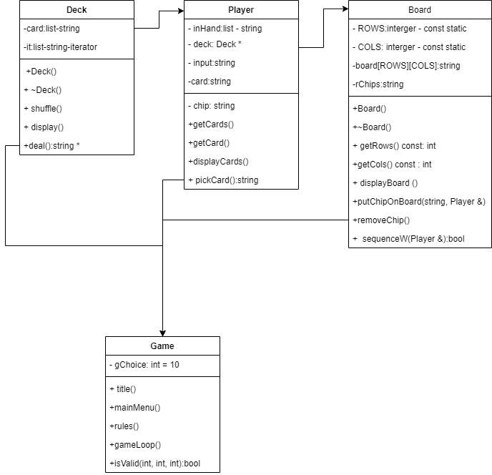

Sample Input/Output
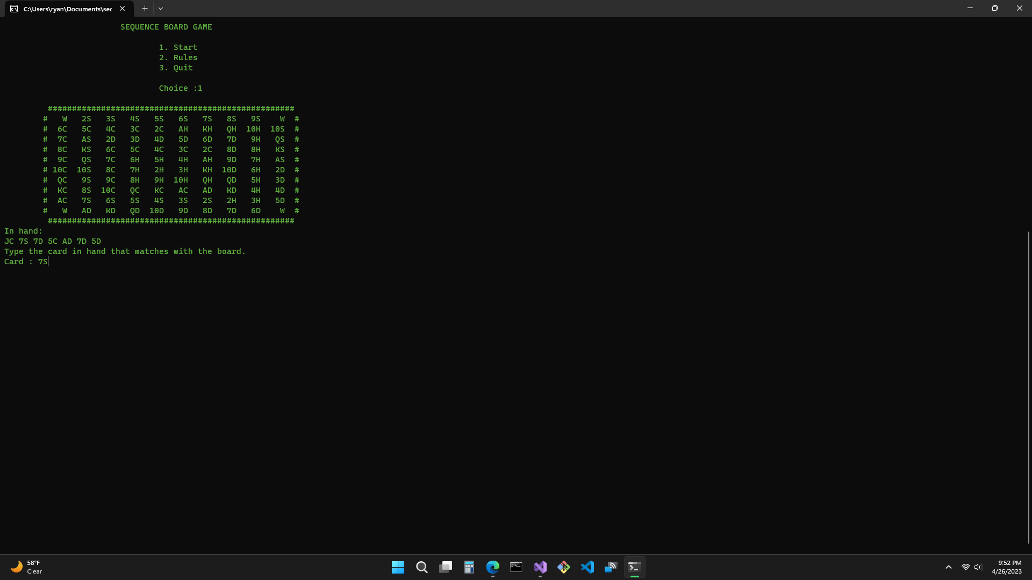
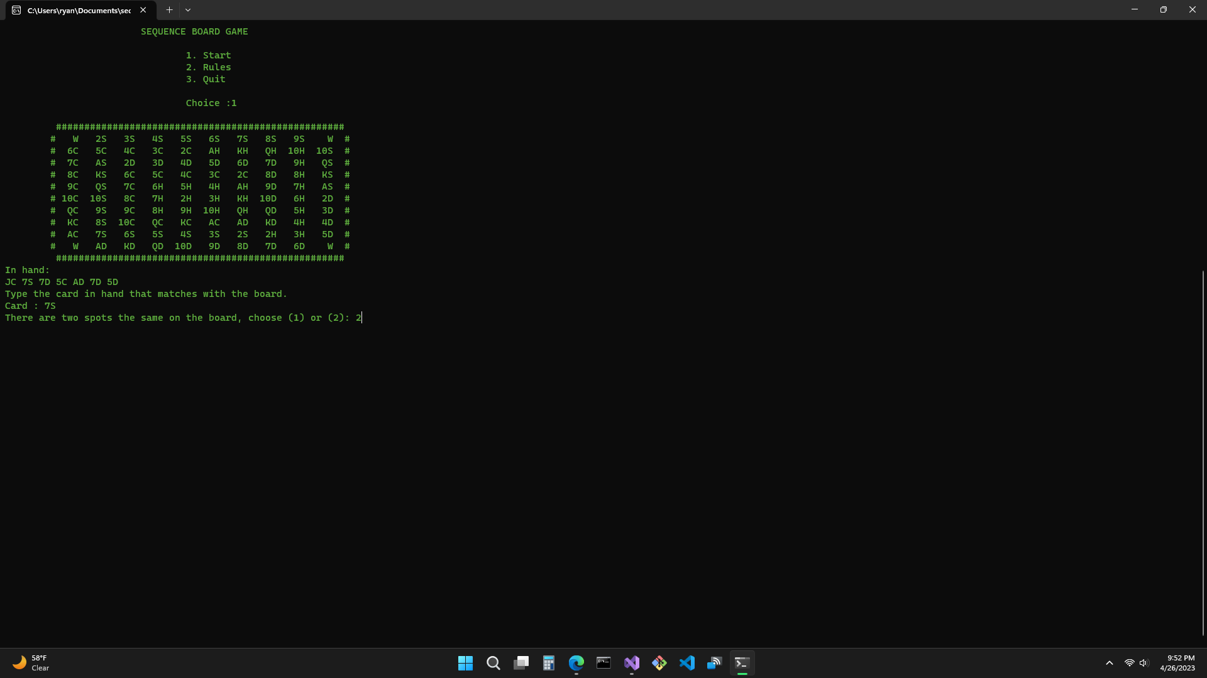
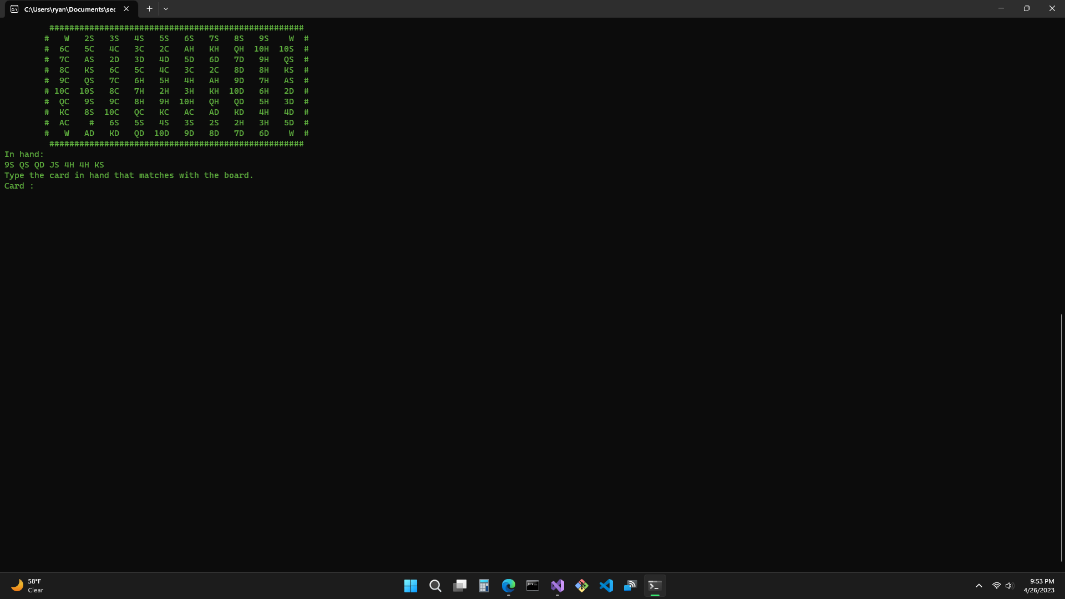

Documentation of Code
Started with the title function that has the Title. Deck class with shuffle, display, and deal. After that being implemented, I started with the player class. Player class has a list as its hand, deck pointer, input for chosen spot, cardFound as a Boolean, and functions like getCards, getCard , displayCards pickCard, and placeChip.
Then made the board class with a string 2d array, 2 constants for the rows and cols and functions display board each time, if the board has a sequence on it. It would loop until the player gets two sequences.
Had a difficult time comparing the players pick card with the board and swapping the 2d array with a chip. Connect 4 was thought about just because you win with 4-in-a-row pieces on the board, like sequence you need 5-in-a-row. Connect 4 was made, what was found in the program to switch players “chips”(string element) on the board, and to see if there was a sequence to see if player had won.
Put everything together in separate header files and cpp files. Tried to connect the classes together to make the game work.

Flow Chart
